

**Product Dissection for Spotify**

**Company Overview:**

Spotify , founded in 2006 by Daniel Ek, former CTO of Stardoll, and Martin Lorentzon, co-founder of Tradedoubler. Spotify is now a global leader in the music streaming industry. Spotify allows users to stream music, create and share playlists, and discover new content based on personal preferences. With millions of active users and an ever-expanding music library, Spotify has become a go-to platform for music lovers worldwide.

### **Product Dissection and Real-World Problems Solved by Spotify:**

Spotify is a music streaming platform, has effectively addressed real-world challenges through its innovative features and functionalities . Users can easily search for songs, albums, and artists of their choice and stream them directly from the platform. Spotify allow users to create, share, and follow playlists, including both personal playlists and public playlists curated by Spotify or other users. Spotify uses advanced algorithms to suggest playlists, songs, and artists based on user activity, listening history, and preferences. Users can follow friends, share music, and see what others are listening to. Beyond music, Spotify also offers podcasts and internet radio stations, further enhancing its content offerings. Spotify operates on a freemium model with free and premium subscription tiers. Spotify pays royalties to artists based on streaming volumes, providing a platform for independent artists and labels to earn revenue.

The platform’s popularity hinges on its ability to provide seamless access to a wide variety of content while offering a personalized experience for users.

In conclusion, Spotify’s product design has successfully tackled real-world problems by creating a platform that provides access to millions of songs anywhere, anytime, through various devices. Through its diverse features, Spotify personalized recommendations, curated playlists, and algorithmic features help users discover new music tailored to their taste provides practical solutions to the evolving needs of its global user base.

**Case Study: Real-World Problems and Spotify’s Innovative Solutions**

Spotify, a leading music streaming service, has revolutionized the way people discover, listen to, and share music. The platform's approach has helped solve several critical real-world problems, not only for music lovers but also for artists and the broader music industry. Below, I will explore specific challenges Spotify has addressed, its innovative solutions, and how these solutions have contributed to the platform's success.

**Problem 1 : Discovering new music in a saturated market**

**Real-World Challenge :** For music lovers, discovering new and diverse music was often difficult in a world overwhelmed by choices. People often stuck to familiar artists and genres, missing out on a broader musical world and discovering new music could feel overwhelming without proper guidance.

**Spotify’s Solution :** Spotify introduced personalized music recommendations as a core feature of its platform. By leveraging machine learning, data analytics, and user behavior tracking, Spotify developed powerful algorithms that analyze users' listening patterns to suggest new music based on personal preferences. Multiple playlists created daily for users, combining songs they love with new songs from artists they might enjoy.

### **Problem 2 : User Engagement and Retention**

**Real-World Challenge :** Keeping users engaged with the platform over time is a major challenge for any service, especially in a competitive landscape where users have many entertainment options. Users may quickly tire of the same music or lose interest if the platform doesn’t continually offer fresh content.

**Spotify’s Solution :** Spotify continuously enhances its content offerings to keep users engaged. This includes personalized playlists, new content types, and improved social features. Spotify introduced social features like Friend Activity, where users can see what their friends are listening to in real-time, and the ability to share playlists on social media platforms. As part of its strategy to retain users, Spotify expanded into podcast streaming. This allowed users to have a broader audio entertainment experience, increasing the time spent on the platform.

### **Problem 3 : Monetization of Music for Artists**

**Real-World Challenge :** Traditionally, music revenue relied heavily on physical album sales, concerts, and radio play. With the advent of digital music, artists faced challenges in monetizing their music effectively. Piracy was a major problem, and even legitimate digital downloads didn’t always provide fair compensation for artists.

**Spotify’s Solution :** Spotify revolutionized the music industry by introducing a streaming model that compensated artists based on the number of streams of their music. Spotify’s model allowed users to access unlimited music for a subscription fee, while artists were paid royalties based on the number of times their tracks were streamed. By giving smaller artists a platform to gain exposure and monetizing streams, Spotify has played a major role in reshaping the economics of the music industry.

**Problem 4 : Music Piracy**

**Real-World Challenge :** Piracy was a major problem in the music industry in the early 2000s. Even after the rise of other digital music stores piracy continued to undercut legitimate sales, harming both artists and the music industry.

**Spotify’s Solution :** Spotify provided a legal, convenient, and affordable alternative to piracy. Through its freemium model, users can access a vast library of music for free with ads or subscribe for an ad-free experience. The ability to stream any song at any time for free or a small monthly fee has made illegal downloading less appealing.

**Conclusion:**

Spotify’s ability to solve these real-world problems has been crucial to its success. By creating personalized music discovery features, improving user engagement, helping artists monetize their music, and addressing piracy, Spotify has changed the landscape of the music industry. Its innovative approach to data-driven music curation, user engagement, and artist compensation has made it the dominant player in the streaming market, offering both users and creators new opportunities in the world of music.

**Schema Description :**

The schema for Spotify involves several entities which include one-to-many and many-to-many relationship with each other. These entities include Users, Song, Artist, Albums, Playlist, Subscription and more. Each entity has specific attributes that describe its properties and relationships with other entities.

**Users**

The User entity stores information about each individual user of the Spotify platform. This includes data about their profile, subscription, and activity on the platform.

#### **Attributes:**

* **user_id** (Primary Key): Unique identifier for each user.
* **email**: The user’s email address
* **username**: The user’s display name.
* **subscription_type**: The user’s current subscription status
* **country**: The country the user is located in.
* **date_joined**: Date when the user registered.

**Song**

The Song entity represents an individual track available on Spotify, which can be associated with an album and an artist.

#### **Attributes:**

* **Song_id** (Primary key): Unique identifier for each song.
* **title** : Name of the song.
* **artist_id** : (Foreign key) linking to the artist who performed the song.
* **album_id** : (Foreign key) linking to the album the song belongs to.
* **release_date**: Date when the song was released .
* **genre**: Genre of the song.

### **Artist**

The Artist entity represents the musicians, bands, or groups who produce music on Spotify. Each song is associated with one artist.

#### **Attributes:**

* **artist_id** (Primary Key): Unique identifier for the artist.
* **name**: Name of the artist.
* **bio**: A short biography of the artist.
* **genre**: The genre(s) the artist belongs to.
* **country**: The artist’s country of origin.

### **Albums**

The Album entity represents a collection of songs by an artist, often released as a cohesive package.

#### **Attributes:**

* **album_id** (Primary Key): Unique identifier for the album.
* **album_title**: Name of the album.
* **release_date**: The album's release date.
* **artist_id** (Foreign Key): References the artist who released the album.
* **genre**: Genre of the album .

### **Playlist**

The Playlist entity represents a collection of songs curated by users or Spotify itself.

**Attributes:**

* **playlist_id** (Primary Key): Unique identifier for the playlist.
* **name**: Name of the playlist.
* **description**: A brief description of the playlist.
* **user_id** (Foreign Key): References the User who created the playlist.
* **created_at**: Timestamp for when the playlist was created.
* **updated_at**: Timestamp for when the playlist was last updated.

### **Subscription**

The Subscription entity tracks the user’s subscription type and status.

#### **Attributes:**

* **subscription_id** (Primary Key): Unique identifier for the subscription.
* **user_id** (Foreign Key): References the **User** who holds the subscription.
* **subscription_type**: Type of plan (e.g., Free, Premium, Family).
* **start_date**: The date when the subscription started.
* **end_date**: The date when the subscription ends or renews.
* **renewal_date**: The date when the subscription is due for renewal.

### **Listening History**

The Listening History entity tracks the songs that a user listens to and the details of each play.

#### **Attributes:**

* **history_id** (Primary Key): Unique identifier for each listening event.
* **user_id** (Foreign Key): References the **User** who listened to the song.
* **song_id** (Foreign Key): References the **Song** that was listened to.
* **timestamp**: The date and time when the song was played.
* **device_type**: Type of device used for listening (e.g., mobile, desktop, smart speaker).
* **duration**: How long the song was played (in seconds)

**Relationship are :**

**User create Playlist**: A user can create many playlists, but each playlist is owned by a single user.

**User Subscription**: A user has one active subscription at a time.

**User‘s Listening History**: A user can have many listening history records, representing each time a song is played.

**Song’s Album**: Each song belongs to an album, but an album can contain multiple songs.

**Artist of Song** : Each song is performed by one artist, but an artist can have many songs.

**Artist followed by User**: A user can follow many artists, and an artist can be followed by many users.

**ER Diagram:**

Let's construct an ER diagram that vividly portrays the relationships and attributes of the entities within the Spotify schema. This ER diagram will serve as a visual representation, shedding light on the pivotal components of Spotify's data model. By employing this diagram, you'll gain a clearer grasp of the intricate interactions and connections that define the platform's dynamics.

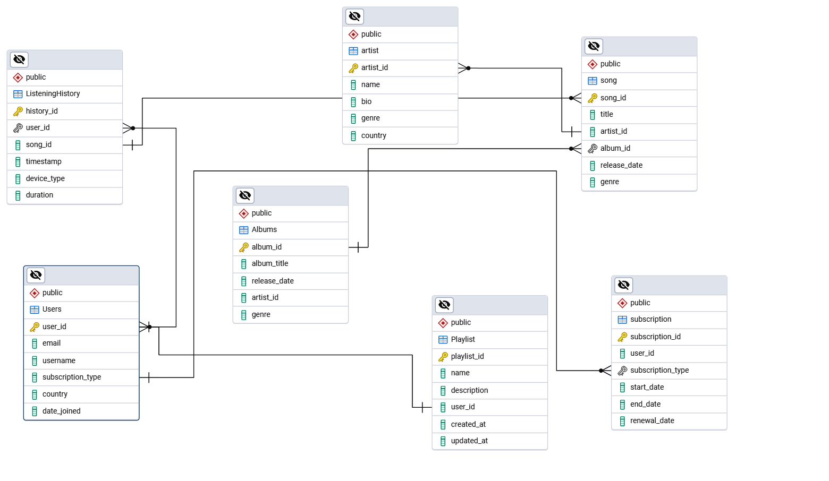

### **Conclusion**

In this case study, we delved into the design of Spotify’s schema and Entity-Relationship diagram. The design ensures that all essential features, such as user management, playlists, music catalog, subscriptions, and recommendations, are well-organized and easily manageable. By focusing on key entities and their relationships, the diagram supports Spotify's core functionalities, ensuring seamless user experience, content discovery, social interactions, and personalized recommendations.